Data sci

Practical 3

height <- c(102, 117, 105, 141,135,115, 138, 144, 157, 100, 131,119, 115,121, 113)

weight <- c(61, 46, 62, 54, 60, 69, 51, 50, 46, 64, 48, 56, 64, 48,59)

student <- lm(weight~height)

student

predict(student, data, frame(height=199), interval="confidence")

plot(student)

you will get 3 graph in output

practical 4

data('AirPassengers')

class(AirPassengers)

start(AirPassengers)

end(AirPassengers)

frequency(AirPassengers)

summary(AirPassengers)

plot(AirPassengers)

abline(reg=lm(AirPassengers~time(AirPassengers)))

cycle(AirPassengers)

plot(aggregate(AirPassengers, FUN=mean))

boxplot(AirPassengers ~ cycle(AirPassengers))

you will get 3 graph one box one single line one in elevation and some written stuff

pratical 5

rainfall <- c(799, 1174, 865.1, 1334.6, 635.4, 918.5, 685.5, 998.6, 985, 882.8, 1071)

rainfall.timeseries <- ts(rainfall, start = c(2012, 1), frequency = 12)

print(rainfall.timeseries)

png(file="rainfall.png")

plot(rainfall.timeseries)

dev.off()

output

you will get some written stuff with rainfall .png photo will generate

inside files.

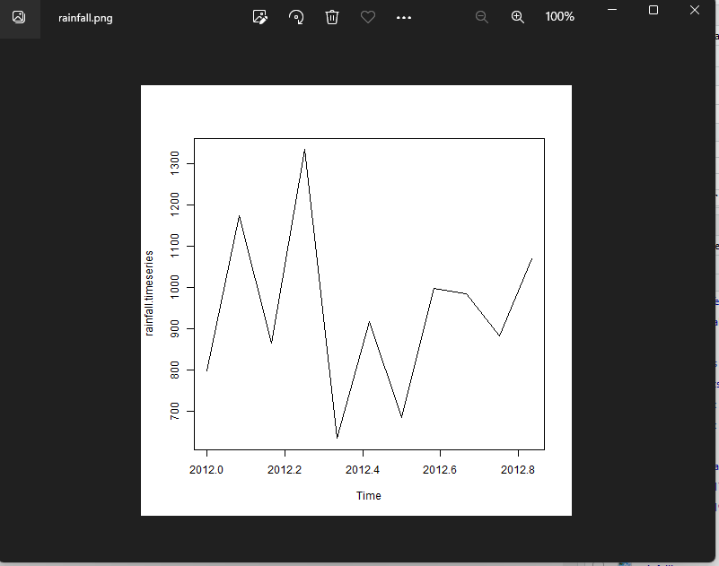

Practical 6

"k-means clustering"

data(iris)

names(iris)

new_data<-subset(iris,select=c(-Species))

new_data

c1<-kmeans(new_data,3)

c1

data<-new_data

wss<-sapply(1:15,function(k){kmeans(data,k)$tot.withinss})

wss

plot(1:15,wss,type="b",pch=19,frame=FALSE,xlab="Number of clusters K",ylab="Total within-clusters sums of squares")

library(cluster)

clusplot(new_data,c1$cluster,color=TRUE,shade=TRUE,labels=2,lines=0)

c1$cluster

c1$centers

"agglomarative clustring"

clusters<-hclust(dist(iris[,3:4]))

plot(clusters)

clusterCut<-cutree(cluster,3)

table(clusterCut,iris$Species)

output

you will get 3 graph

dendrogram,color graph,and simple line graph

pratical 7

decision tree

#Load the party package. It will automatically load other

#dependent packages.

insatll.packages("party")

library(party)

#Create the input data frame.

input.dat<-readingSkills[c(1:15),]

#Give the chart file a name.

png(file="decision_tree.png")

#create the tree.

output.tree<-ctree(nativeSpeaker~age+shoeSize+score,data=input.dat)

#Plot the tree.

plot(output.tree)

#Save the file.

dev.off()

pratical 8

dataf<-seq(1,20,by=1)

dataf

mean(dataf)

sd(dataf)

a<-t.test(dataf,alternate="two.sided",mu=10,conf.int=0.95)

a

a$p.value

a$statistic

(10.5-10)/(sd(dataf)/sqrt(length(dataf)))

length(dataf)=1

length(dataf)

dataf

dataf<-seq(1,20,by=1)

length(dataf)-1

output will be return stuff no graph no photo

pratical 9

data("warpbreaks")

head(warpbreaks)

summary(warpbreaks)

Model_1<-aov(breaks~wool+tension,data=warpbreaks)

summary(Model_1)

plot(Model_1)

Model_2<-aov(breaks~wool+tension+wool:tension,data=warpbreaks)

summary(Model_2)

plot(Model_2)

output

wirttten stuff and 4 graph